# Project Assessment: Create and style a website

## Criteria

### Unit code, name and release number

ICTWEB414 - Design simple web page layouts (1)

ICTWEB429 - Create a markup language document to specification (1)

ICTWEB431 - Create and style simple mark-up language documents (1)

### Qualification/Course code, name and release number

ICT40118 - Certificate IV in Information Technology

## Student details

### Student number

804693424

### Student name

Richard Kim

## Assessment Declaration

* This assessment is my original work and no part of it has been copied from any other source except where due acknowledgement is made.
* No part of this assessment has been written for me by any other person except where such collaboration has been authorised by the assessor concerned.
* I understand that plagiarism is the presentation of the work, idea or creation of another person as though it is your own. Plagiarism occurs when the origin of the material used is not appropriately cited. No part of this assessment is plagiarised.

### Student signature and Date

Richard Kim, 08/06/2021

Version: 1.0

Date created: 13 October 2019

Date modified: 13 November 2019

For queries, please contact:

Technology and Business SkillsPoint

Location: Ultimo

© 2019 TAFE NSW, Sydney  
RTO Provider Number 90003 | CRICOS Provider Code: 00591E

This assessment can be found in the [Learning Bank](https://share.tafensw.edu.au/share/access/searching.do?doc=%3Cxml%2F%3E&in=P7ac4831b-430a-4b8d-8b56-f7b32ed5b9cf&q=&type=standard&sort=rank&dr=AFTER)

The contents in this document is copyright © TAFE NSW 2019, and should not be reproduced without the permission of the TAFE NSW. Information contained in this document is correct at time of printing: 8 June 2021. For current information please refer to our website or your teacher as appropriate.

## Assessment instructions

Table 1 Assessment instructions

| Assessment details | Instructions |
| --- | --- |
| **Assessment overview** | The objective of this assessment is to assess your knowledge and performance to create and save basic mark-up language documents, including web page components, and create cascading style sheets (CSS) to define and style a website, using a text editor. |
| **Assessment Event number** | 2 of 3 |
| **Instructions for this assessment** | This is a project-based assessment and will be assessing you on your knowledge and performance of the units.  This assessment is in four parts:   1. Create and style the website 2. Test and validate the website 3. Hand over website 4. Correct errors.   The assessment also contains:   * Assessment Checklist * Observation Checklist * Assessment Feedback.   **Check the Assessment and Observation checklists to ensure that you’ve covered all the required tasks.** |
| **Submission instructions** | On completion of this assessment, you are required to upload it or hand it to your assessor for marking.  Ensure you have written your name at the bottom of each page of your assessment.  Submit the following documents for each part:   * Part 1: Create and style the website   + A zipped folder containing all files in your website * Part 2: Test and validate the website   + Test results report * Part 3: Hand over website   + You will be observed by your assessor * Part 4: Correct errors   + A zipped folder of the corrected website   + A document explaining the errors and processes.   It is important that you keep a copy of all electronic and hardcopy assessments submitted to TAFE and complete the assessment declaration when submitting the assessment. |
| **What do I need to do to achieve a satisfactory result?** | To achieve a satisfactory result for this assessment all questions must be answered correctly and all items in the Assessment and Observation Checklists must be marked Satisfactory. |
| **Assessment conditions** | Skills must be demonstrated in a workplace or simulated environment where conditions are typical of those in an ICT working environment or workplace. |
| **What do I need to provide?** | * USB drive or other storage method with enough free space to save work to.   To complete this assessment off campus, you will need:   * A personal computer with internet access * Text editor/s software e.g. Notepad, Sublime, Atom (No auto generating software e.g. Dreamweaver). |
| **What will the assessor provide?** | * Access to the Learning Management System * Scenario documents as outlined in assessment:   + *Client resource folder* (Cl_LayoutStyleMarkupDocs_AE_SR1.zip)   + *Website folder with errors* (Cl_LayoutStyleMarkupDocs_AE_Pro_2of3_SR1.zip) * Classroom computers with internet access * Access to common web browsers * Text editor/s software e.g. Notepad, Sublime, Atom (No auto generating software e.g. Dreamweaver) * Users for testing e.g. other students |
| **Due date and time allowed** | Indicative time to complete assessment:   * Part 1: Three hours * Part 2: One hour * Part 3: 15 mins * Part 4: 45 mins. |
| **Assessment location** | Part 3 will be completed in the classroom.  All other parts may be completed outside of the classroom. |
| **Supervision** | Parts 1, 2 and 4 are an unsupervised, take-home assessment. Your assessor may ask for additional evidence to verify the authenticity of your submission and confirm that the assessment task was completed by you. |
| **Reasonable adjustment** | If you have a permanent or temporary condition that may prevent you from successfully completing the assessment event(s) in the way described, you should talk to your assessor about ‘reasonable adjustment’. This is the adjustment of the way you are assessed to take into account your condition, which must be approved BEFORE you attempt the assessment. |
| **Assessment feedback, review or appeals** | Appeals are addressed in accordance with [Every Student’s Guide to Assessment in TAFE NSW.](https://www.tafensw.edu.au/documents/60140/76288/Every+Students+Guide+to+Assessment+in+TAFE+NSW.pdf/cc2b5417-89a6-08f7-9a67-a0c2ff1e26ee) |

## Specific task instructions

### Scenario

Sorrento by the Sea is a luxury apartment located on the picturesque Mornington Peninsula, an approximate one-hour scenic drive from Melbourne. The owners of this apartment have contacted you to build their website. They want to promote their apartment and help increase occupation during the off-season times, so they need it completed in four weeks.

The owners feel the best way to do this is to highlight unique attractions of the area, such as the calm front beach on Port Phillip Bay and the wilder surfing beaches on the Bass Strait side, coastal walks, swimming with dolphins and fishing. These cater for all ages and tastes.

They would like to show a [video of Sorrento](https://www.youtube.com/watch?v=KE0SbDBw-ok) on their home page.

The website must have a Contact page with an enquiry form to collect name, email address and booking date (this should go to another page in the website), map (this can be a screenshot image) and contact number. They want to focus on the ease of access for nearby Melbourne residents and have provided an enticing pricing structure for people who want to get away from the city for a few days. They also want to highlight the pet-friendly policy of this apartment.

Download and unzip the *resource folder* (Cl_LayoutStyleMarkupDocs_AE_SR1.zip) from the client. It contains images of the apartment and the local features, some general information about the business, unit and area, a logo and icons.

They would like a two-column layout that prints appropriately (i.e. include print styles). Styles and colours to include in the site are listed in the technical specifications below.

Table : Technical specifications

|  |  |
| --- | --- |
| Feature | Associated style |
| Global font hierarchy | Helvetica, Calibri, suitable default |
| Primary navigation links | #4d1d18, remove default underline |
| Navigation hover effect | #555 |
| Major heading | #87423c, 36 pixels |
| Sub-headings | #4d1d18, 24 pixels |
| Paragraph text | 150% line height |
| Content links | #87423c |
| Footer text and links | #87423c |

## Part 1: Create and style the website

Using a text editor and the mark-up language identified in Assessment 1, create the structured and formatted website for the client. **Note: You must not use a program that generates code**. Refer to the client’s requirements and organisational standards, as well as relevant industry and accessibility standards, and ensure that your website follows these.

Include the following:

1. Create and use an appropriate directory structure for the website.
2. Build the page structure for your webpages using essential basic elements.
3. Create at least three pages using the supplied content (text and images) from the client and appropriate web page components, according to the measurements in your wireframe.
4. Each page must include the following elements, positioned according to the measurements in your wireframe:
   * A navigational menu of text links providing access to all pages
   * A footer with appropriate utility links and social media icons
   * Company logo, which includes a link back to the home page
   * A current page indicator to clearly show a visitor where they are within the site.
5. Use semantically-correct structural mark-up to define additional sections of each page as needed.
6. Style, format and lay out the pages using CSS:
   * Use one external CSS file for all styles i.e. no inline or internal styles
   * Use consistent styles and layout across the site, including appropriate use of font stack, colours, line-spacing, etc.
   * Do not add unnecessary elements or attributes – use existing elements as selectors wherever possible
   * Use ‘class’ and ‘id’ attributes appropriately
   * Style hyperlinks appropriately for different states, such as visited and hover – do not use the default styles
   * Style the current page indicator appropriately.

## Part 2: Test and validate the website

Now that you have completed creating the website, it’s time for you to test and validate it. Record your test results (including screenshots where indicated) in a word-processed document to provide to the client. Use specialised language where appropriate.

1. Using the test approach and test cases that you created in Assessment 1, test your website and complete your testing checklist. Make sure that your testing includes the following:
   * Test your website in two common browsers; if you have difficulty accessing different browsers and versions you can use an online testing site such as [Browser Shots](http://browsershots.org/) (include screenshots)
   * Validate your website to ensure it meets web standards (include screenshots).
2. You must correct any issues and re-test your website until it displays correctly. Discuss this re-testing, including screenshots of different versions.
3. Explain the testing process and the results, including any outstanding issues and corrective actions.

## Part 3: Hand over website

Now that you have completed your website, you need to meet with your client in a role play of 10-15 minutes to demonstrate it and obtain their acceptance.

* For face-to-face students, your assessor will observe the role play and complete the Observation Checklist.
* For online students, make an appointment with your assessor for an online meeting.
* Make sure that you use:
  + clear and detailed verbal language to convey explicit information.

Role play participants:

* **Client** – your assessor will participate as the Client
* **Website developer** (this is you).

Ensure that you include the following in your role play:

1. Demonstrate finished website to client.
2. Provide test results to client, explaining any outstanding issues and corrective actions.
3. Correct any issues that the client brings up.
4. Obtain the client’s acceptance of the finished website.

## Part 4: Correct errors

You have developed a website for another client, which displays two error messages during testing and validation, as follows.

1. Review the files in the *website folder* (Cl_LayoutStyleMarkupDocs_AE_Pro_2of3_SR1.zip). Determine the causes of the errors using a problem-solving process and make the appropriate changes to the website files.

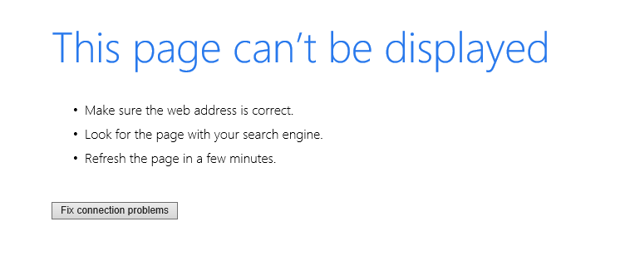

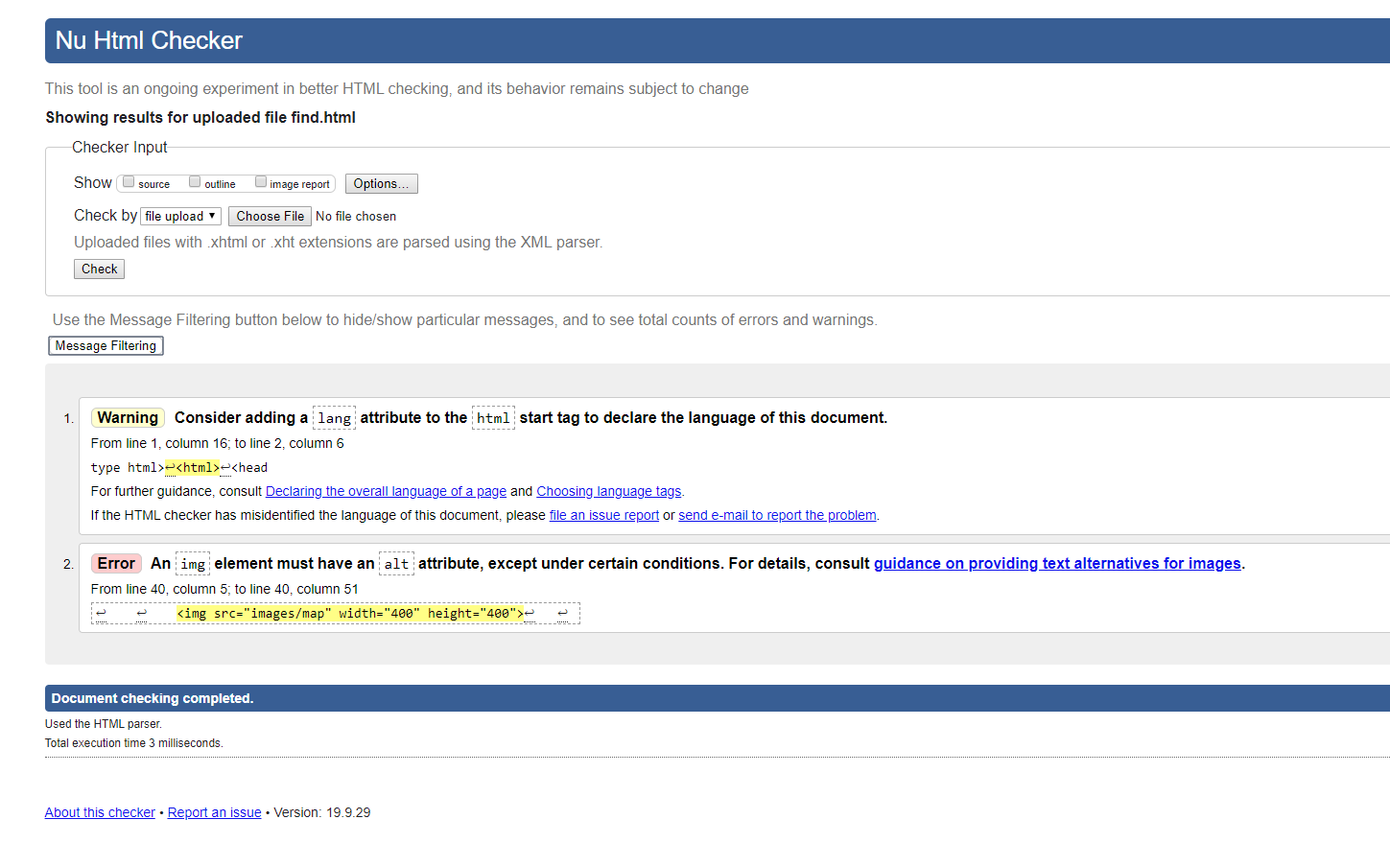

1. In a word-processed document explain the errors that you found and the problem-solving processes that you used to determine the solution. Include evidence such as mind maps, decision trees etc.

## Assessment Checklist

The following checklist will be used by your assessor to mark your performance against the assessment criteria of your submitted project. Use this checklist to understand what skills and/or knowledge you need to demonstrate in your submission. All the criteria described in the Assessment Checklist must be met. The assessor may ask questions while the submission is taking place or if appropriate directly after the task/activity has been submitted.

Table : Assessment Checklist

| TASK/STEP # | Instructions | S | U/S | Assessor Comments |
| --- | --- | --- | --- | --- |
| **Part 1.1** | Creates appropriate directory structure |  |  |  |
| **Part 1.2** | Creates at least three webpages, structured using essential basic elements |  |  |  |
| **Part 1.3, 1.4** | Includes the required web page components and supplied content, navigation, footer, logo and current page indicator |  |  |  |
| **Part 1.3** | Web page layout follows measurements in wireframe |  |  |  |
| **Part 1.5** | Uses semantically-correct structural mark-up |  |  |  |
| **Part 1.6** | Styles, formats and lays out pages using CSS according to requirements |  |  |  |
| **Part 2.1** | Tests website in two browsers using test approach and test cases |  |  |  |
| **Part 2.1** | Validates website to meet web standards |  |  |  |
| **Part 2.2** | Corrects any errors |  |  |  |
| **Part 2.3** | Explains the testing, any outstanding issues and corrective actions |  |  |  |
| **Part 4.1** | Corrects website errors |  |  |  |
| **Part 4.2** | Explains the errors and the problem-solving processes used, including evidence |  |  |  |

## Observation Checklist

The Observation Checklist will be used by your assessor to mark your performance in Part 3 of this assessment. Use this Checklist to understand what skills you need to demonstrate in the role play. The Checklist lists the assessment criteria used to determine whether you have successfully completed this assessment event. All the criteria must be met. Your demonstration will be used as part of the overall evidence requirements of the unit. The assessor may ask questions while the demonstration is taking place or if appropriate directly after the task/activity has been completed.

Table 2 Observation Checklist

| Task # | Task/Activity Performed | S | U/S | Assessor Comments (Describe the student’s ability in demonstrating the required skills and knowledge) |
| --- | --- | --- | --- | --- |
| **Part 3** | Uses clear and detailed languageto convey explicit information |  |  | *Date of Observation:*  *Assessors are to record their observations in sufficient detail to demonstrate their judgement of the student’s performance against the criteria required.* |
| **Part 3.1** | Demonstrates website |  |  |  |
| **Part 3.2** | Provides test results and explains issues |  |  |  |
| **Part 3.3** | Corrects any issues from client |  |  |  |
| **Part 3.4** | Obtain client’s acceptance |  |  |  |

## Assessment Feedback

### Assessment outcome

Satisfactory

Unsatisfactory

### Assessor Feedback

Has the Assessment Declaration been signed and dated by the student?

Are you assured that the evidence presented for assessment is the student’s own work?

Was the assessment event successfully completed?

If no, was the resubmission/re-assessment successfully completed?

Was reasonable adjustment in place for this assessment event?  
*If yes, ensure it is detailed on the assessment document.*

Comments:

### Assessor name, signature and date:

### Student acknowledgement of assessment outcome

Would you like to make any comments about this assessment?

### Student name, signature and date

Richard Kim, 08/06/2021

***NOTE: Make sure you have written your name at the bottom of each page of your submission before attaching the cover sheet and submitting to your assessor for marking***